So in the last lesson we have learned about variables and data types , we have learned a lot about them. So in this video, we will learn about this start function and this update function as marked below:-

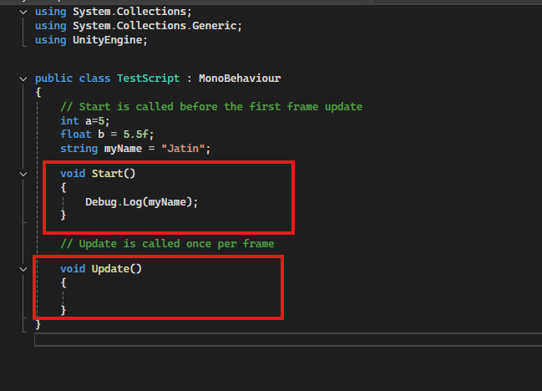

So functions are basically something that does some tasks which are written inside them. So it takes some tasks and it does that whenever we wanted to do that. So here we are talking about this start function and this update function. Inside curly braces comes the code inside which we write all our code that we want the function to do what this start function does it gets called whenever this script gets called for the very first time. So here, as you can see, we have actually attached the script to a game object as marked below

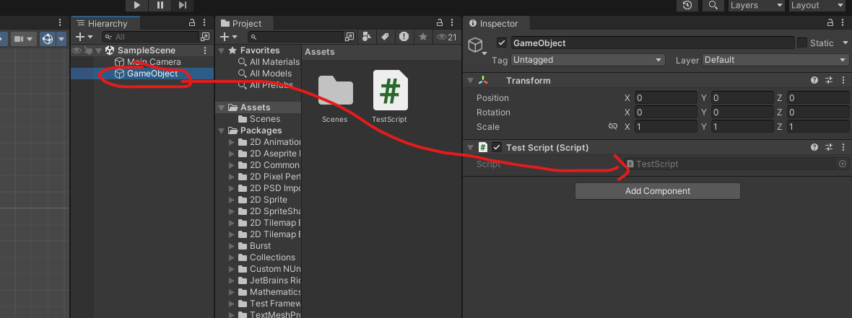

, which is inside the scene. So whenever we run a game, this script gets called, which is a part of this game object. So whenever this script gets called, the start function gets called the very first time. So it gets it gets called only once. OK, if you want to start wanting to get called more than one time by default, it gets called only once. OK, that is when the script gets started. So if we type Debug.log inside the Start method and pass the string In start. So whenever we run our game by clicking on Play button.

1:50